

User Manual

version 0.5

http://sourceforge.net/projects/php-addressbook

table of content

1. Features 3
2. Target of this manual 3
3. Preparation 3
4. Installation 3
4.1. Validate your installation 4
5. Setup users and passwords 4
5.1. Setup read-only users 5
6. Additional integrations 6
7. Facebook / Twitter / Google integration 6
8. Change look & feel 7
9. Upgrade your installation 7
10. Improve the Address Book 8
11. Access your addresses 8
11.1. iPhone 8
11.2. Android 8
12. Manage your addresses 8
13. Import / Export addresses 9

Features
- Manages contacts & groups
- Exports Excel, vCard - Import vCard, LDIF (ThunderBird)
- Show geographical maps of groups
- Protects the site with a login
- Detects and displays over 12 languages
- Displays the next birthdays
- Optimized for Browser, iPhone and Print
- Support ActiveSync for iPhone and Android
- Shows birthdays in iPhone calendar
- Authentication based on User/Password or IP-Address/-Range.

Target of this manual
This manual shall give you a quick help to get things done.

Preparation
You need to have a running installation of:
LAMP (Linux, Apache, MySQL, PHP)
WAMP (Windows, Apache, MySQL, PHP)

Your PHP should be at least version 5.

Download from sourceforge: http://php-addressbook.sf.net/latest.html

Installation
Extract downloaded .zip into your PHP directory i.e. make a folder named addressbook so you find it.

- if you use Linux it might be helpful to apply this to this folder chmod –R 0777
- create an empty database with i.e. phpMyAdmin and call it 'addressbook8'.
- import into this database the 'addressbook.sql' from the extracted folder.
- if you haven't already done it, upload all files to your website, e.g. to „yourdomain.com/addressbook“ or in your PHP folder in Linux i.e. /var/www/addressbook
- Edit the file « config/cfg.db.php » according to your PHP/MySQL installation information.

$dbname = "test"; change to addressbook8 or whatever you've chosen before
$dbserver = "localhost"; your path to the database
$dbuser = "root"; your root
$dbpass = ""; your database password

how it looks in the text editor
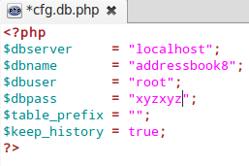

Validate your installation
Open your webbrowser and try to reach with « diag.php », i.e.
yourdomain.com/addressbook/diag.php
localhost/addressbook/diag.php

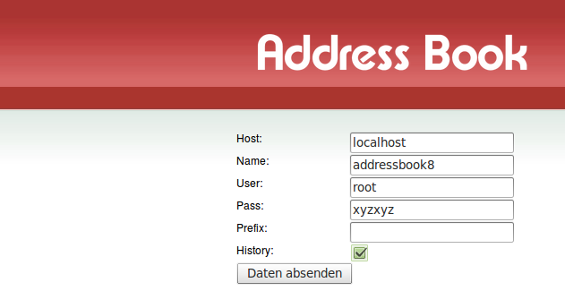

Setup users and passwords
You will need users with administrative privileges to add / delete / change things in the database and other users. To setup these users you will edit the file « config/cfg.user.php »
Their entry must be in relation to your setup in the MySQL database, which you can control via phpMyAdmin as example.

Add yourself as a « root » user

$userlist['admin']['pass'] = "secret";
$userlist['admin']['role'] = "root";

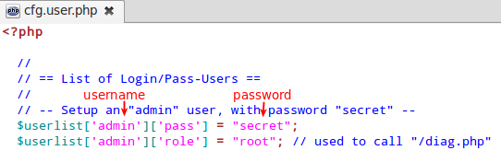

username function be root

If you want to add more people with the same privileges (with read/write access), just add in this section another user like:

$userlist['somebody']['pass'] = "secret-too";

of course you should change the 'somebody' and the password 'secret-too' appropriately!!

Setup read-only users
In order to activate this section you need to 'uncomment' it. This means you have to remove the forward slash '/* and '*/'' in this area.

A read-only user
« view » using role « readonly » assigned

$userlist['view']['pass'] = "secret-light";
$userlist['view']['role'] = "readonly";

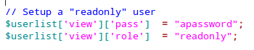

A read-only user - restricted to one group
Allow the user « view » only to access « mygroup »
if you want to use one of these sections you need to 'uncomment' it. This means you have to remove the forward slash '/'.

$userlist['mygroup']['pass'] = "apassword";
$userlist['mygroup']['role'] = "readonly";
$userlist['mygroup']['group'] = "mygroup";

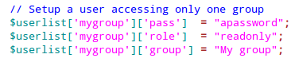

A readonly user - restricted to IP-Ranges

Add your company’s IP-Range (or Proxy IP-addresses) as editors
$iplist['169.168.1.*']['role']= "editor";

OR just add your company « read only »
$iplist['169.168.1.*']['role']= "readonly";

Setup users in database
You may manage your users in the database too, just uncomment the « usertable » line:
$usertable = 'user';
Notice: This is not an officially supported feature, as there are not yet any tools available. If you use it, just don’t forget to encode the password with MD5.

First example, Add a user to the domain „0“:
INSERT INTO user(domain_id, username, md5_pass) VALUES(0, 'myuser', md5('hissecret'));

Second example, give every new user a new domain:
INSERT INTO addr_user(domain_id, username, md5_pass)
SELECT max(domain_id)+1 domain_id
, 'myuser' username
, md5('hissecret') md5_pass
from user;

Additional integrations
Make use of your preferred provider Yahoo-, Gmail-, Hotmail for mailing.
By default mail is sent over a « mailto: » call, usually opening your default-mail-client, i.e. Outlook. To change this behaviour you can make changes in

1) Edit « config/cfg.mail.php »
2) Uncomment your prefered mail provider.
// $webmail_provider = "gmail";
// $webmail_provider = "yahoo";
// $webmail_provider = "hotmail";

iPhone / Android synchronization

Keeping the mobile phone and the addressbook in sync is invaluable, as you will never again forget a copy paste in any direction.

1. Unzip « z-push.zip » to « z-push »
2. Add this to your « .htaccess » especially the last line !!
Options +FollowSymlinks
RewriteEngine on
RewriteBase /

RewriteRule .* - [E=HTTP_MS_ASPROTOCOLVERSION:%{HTTP:Ms-Asprotocolversion}]
RewriteRule .* - [E=HTTP_X_MS_POLICYKEY:%{HTTP:X-Ms-Policykey}]
RewriteRule .* - [E=HTTP_AUTHORIZATION:%{HTTP:Authorization}]

RewriteRule ^Microsoft-Server-ActiveSync(.*)$ addressbook/z-push/index.php?%{QUERY_STRING}
Check if everything installed by calling this URL : Fehler! Hyperlink-Referenz ungültig.

You will be asked for a valid user and password.
tbd

A screen looking like this should appear, if everything looks ok:
tbd

Facebook / Twitter / Google integration
Tbd, coming soon.

Change look & feel
Disable Google-Maps
You may for security reasons disable Google-Maps, as all addresses are geocoded once at Google :
// $google_maps_keys[''] = "";

Rows displayed on « index.php »
You may display other columns, just remove the preceding forward slash '//'.
$disp_cols
= array( "select"
, "photo"
, "last_first"
// , "lastname"
// , "firstname"
, "address"
, "all_emails"
// , "email"
, "all_phones"
// , "telephone"
// , "home"
// , "mobile"
// , "work"
// , "fax"
, "edit"
, "details"
);

Upgrade your installation
Download the latest version from sourceforge: http://php-addressbook.sf.net/latest.html

Backup or Rename your old « addressbook » :
Rename the directory, e.g. from « addressbook » to « addressbook.backup »
… OR Download the current directory to your PC
… OR Create a .zip with « compress addressbook »

Backup your database with a full dump/export or at least with this command.
create table addressbook_backup as select * from addressbook ;

3a) Extract the „/_upgrades“ directory on your PC
3b) Apply all patches greater your old version to the database (e.g. with phpMyAdmin)

4a) Upload all files to your website, e.g. to „yourdomain.com/addressbook“
4b) Copy the old config to the new config.

$dbname = "test"; change to addressbook8 or whatever
$dbserver = "localhost"; your path to the database
$dbuser = "root"; your root
$dbpass = ""; your database password

5) If it works, enjoy and revert using first the backup file of your old version and post all bugs.

Improve the Address Book
Fix your language
Got to the « include » directory and search your translation.xx.php.
If you have any questions, feel free to post it to the forum.

Fix your address guess
tbd

Fix your layout
tbd

Develop your features
If you have any good contribution, feel free to post it to the forum.
Fork from GitHub: https://github.com/chatelao/php-addressbook

Access your addresses
Over the web
tbd

Over the mobile phone
e-Mail : <any@yourdomain.com>
Server : <yourdomain.com>
Domain : [empty]
User : same as web access
Password: same as web access
SSL : Depending on your server configuration

iPhone
Setup account → Mail → Exchange → <yourdomain.com> (Disable SSL, not available)
http://simultaneouspancakes.com/Lessons/2010/06/24/connecting-an-iphone-4-to-exchange

Android
http://portal.smartertools.com/kb/a2772/setup-an-android-phone-or-tablet-for-exchange-activesync

Over the database interface
Vw_addressbook
Vw_addressbook_deleted

Over e-Mail
tbd, coming soon

Manage your addresses
Search an address
Just type the name or address in the field on the first page.
Select the group concerned, if you know wish to select people out of a group.

Add an address
With the web interface
tbd

With the E-Mail interface
Tbd, coming soon

With your mobile phone
Install the „ActiveSync“ support as described in chapter xxx.

Edit an address
With the web interface
With your mobile phone

Import / Export addresses

